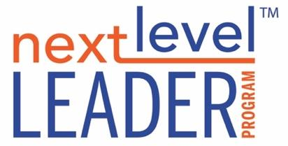

**PREPARING FOR STRATEGY**

One of the best places to start in developing a strategy is to perform what is traditionally called a SWOT Analysis (Strengths, Weaknesses, Opportunities, Threats). This is a little misleading because people will often do this exercise in the order of the letters, but this is a mistake.

The Strengths and Weaknesses of the organization are always meant to be relative to the Opportunities and Threats of the external market conditions.

This is also a helpful starting point when you know you need to develop a strategy but are struggling to get the creative juices flowing.

So the sequence should look like this:

**EXTERNAL CONDITIONS**

1. **Opportunities: *Reflect,research, and describe the external market conditions that represent specific opportunities that impact or could be leveraged by the organization. (This could include large scale forces like global, cultural, political, economic, etc. Or it could include more local trends and shifting conditions.)***
2. **Threats: *Reflect,research, and describe the external forces that represent a threat to the organization.***

**ORGANIZATIONAL CONDITIONS**

1. **Weaknesses: *In response to the external conditions, in what ways might the organization be vulnerable? (This could include staffing, structure, finances, morale, etc.)***
2. **Strengths: *In response to the external conditions, in what ways is the organization well positioned to take advantage of market opportunities?***