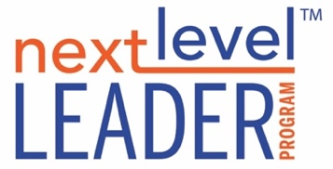

**PENCIL PROCESS FORM**

Name:

Company:

Date:

**OFFERS**

The following list represents what this leader offers another person or team. An offer isn’t always a gift; sometimes we give something that matters to us, but not to others. Receivers should read list below and put one of the letters below next to each offer:

D = An offer I really appreciate*,* ***desire,*** or need

A = An offer I can ***accept***, but is not a need for me

R = An offer I will need to ***refuse***.

[Instructions: make a list of as many behaviors, attributes, or contributions that you feel add value to the team]

**What I Offer:**

•

**Questions for the Receivers:**

Is there anything significant you experience this person offers that they did not list?

**REQUESTSFERS**

The following list represents what this leader requests of the team, a request could be honored, or complied with, need clarification, or in some cases declined. Receivers should read these requests and put a letter below next to each request:

H = A request I am glad to ***honor***

C = A request will ***comply*** with if needed

D = A request I must respectfully ***decline***

I = Need more ***information*** to clarify

[Instructions for making requests: List out the requests you may have of others. Specify who the request is addressed to, it could be the team or individuals. Focus your requests on specific behaviors or words, rather than feelings, intent, or character. It helps to frame your request using phrases like “Would you be willing to…” “Are you able to…” Be mindful of the number of requests you are making (more than 6 can get a little overwhelming. Put the most important ones first.]

**My Requests:**

1.

2.

3.

4.

5.

6.